**Introduction**

**1. Overview and Significance in the AI Era**

Software testing is one of the most vital components in the modern software development lifecycle (SDLC). As applications scale and integrate with technologies like Artificial Intelligence (AI), Machine Learning (ML), cloud computing, and the Internet of Things (IoT), ensuring their correctness, reliability, and performance becomes a top priority. Testing is no longer viewed as a concluding step in the development pipeline but as a continuous, integrated process that spans across all phases of software engineering.

In AI-driven systems, where outcomes can often be non-deterministic and data quality plays a central role, software testing demands even more attention. Models must not only be accurate but also interpretable, robust, and unbiased. These additional constraints make the testing process more complex and context-dependent. As a student of Computer Science specializing in Artificial Intelligence and Machine Learning, this course served as a crucial addition to my academic journey, strengthening my understanding of how AI systems can be rigorously tested and validated before deployment.

The online course titled *“Introduction to Software Testing”* offered a structured and in-depth walkthrough of software testing fundamentals, both from traditional and modern (agile) perspectives. It covered essential concepts such as unit testing, integration testing, system testing, and acceptance testing, along with various testing approaches like black-box, white-box, and exploratory testing. I also gained hands-on experience with tools such as JUnit5 for test-driven development (TDD), and Cucumber for behaviour-driven development (BDD), enabling me to apply what I learned in practical coding environments.

Furthermore, the course delved into automation testing frameworks, continuous integration/continuous deployment (CI/CD) pipelines, and tools like Selenium, Jenkins, and Travis CI. These are essential technologies used in real-world agile software development teams. The distinction between static and dynamic testing, the role of regression and sanity tests, and the application of usability and security testing techniques were also covered extensively.

The role of the Software Development Engineer in Test (SDET) was introduced as an emerging and increasingly important hybrid role in the industry—someone who possesses the coding skills of a developer and the critical eye of a tester. This aligns closely with the current trends in AI software engineering, where code correctness, testability, and automation must go hand-in-hand with performance and scalability.

This report consolidates the knowledge and tools I acquired from the course and serves as a written representation of both theory and application. The concluding section of the report will include a small simulation of a software testing environment—demonstrating real-time application of TDD and BDD using Java and Python-based tools. This simulation will provide a practical perspective on how modern testing frameworks ensure the quality of AI-driven applications in production settings.

**2. Software Testing Requirements & Checklist**

**2.1 Testing Requirements**

Before initiating any form of software testing, certain foundational elements must be in place to ensure that the process is effective, traceable, and aligned with project goals. These testing requirements define what needs to be tested, how it will be tested, and what outcomes are expected. Especially in AI-driven development, where dynamic behaviour and learning models are involved, clearly defined requirements are essential to manage the scope and complexity of testing.

**Essential Software Testing Requirements:**

* **Detailed Software Requirements Specification (SRS):** A well-documented list of features, user stories, and functional expectations.
* **Defined Test Objectives:** Clear goals for each phase of testing—unit, integration, system, and acceptance.
* **Test Plans and Test Cases:** Predefined plans and test cases based on business and technical requirements.
* **Test Data Preparation:** Proper datasets for functional, boundary, and edge case testing—especially relevant for AI/ML systems where data drives outcomes.
* **Test Environment Setup:** Configuration of hardware, software, servers, databases, and networks to simulate the production environment.
* **Traceability Matrix:** Mapping of requirements to test cases for full coverage and to avoid omissions.
* **Risk Assessment and Priority Tagging:** Identifying high-risk functionalities and prioritizing test cases accordingly.

**2.3 Test Automation Pyramid**

The **Test Automation Pyramid** is a conceptual framework that guides the distribution of different types of tests within a software system. The idea is to write more low-level tests (like unit tests), fewer mid-level (integration), and even fewer high-level (UI or end-to-end) tests. This structure enhances maintainability, speed, and efficiency in automated testing.

**Pyramid Levels Explained:**

* **Unit Tests:** Verify individual functions or components. Fast and isolated. Tools: JUnit, PyTest.
* **Integration Tests:** Ensure multiple components or systems work together. Tools: JUnit, TestNG.
* **UI Tests / End-to-End:** Simulate real user workflows. Slower and more brittle. Tools: Selenium, Cypress.

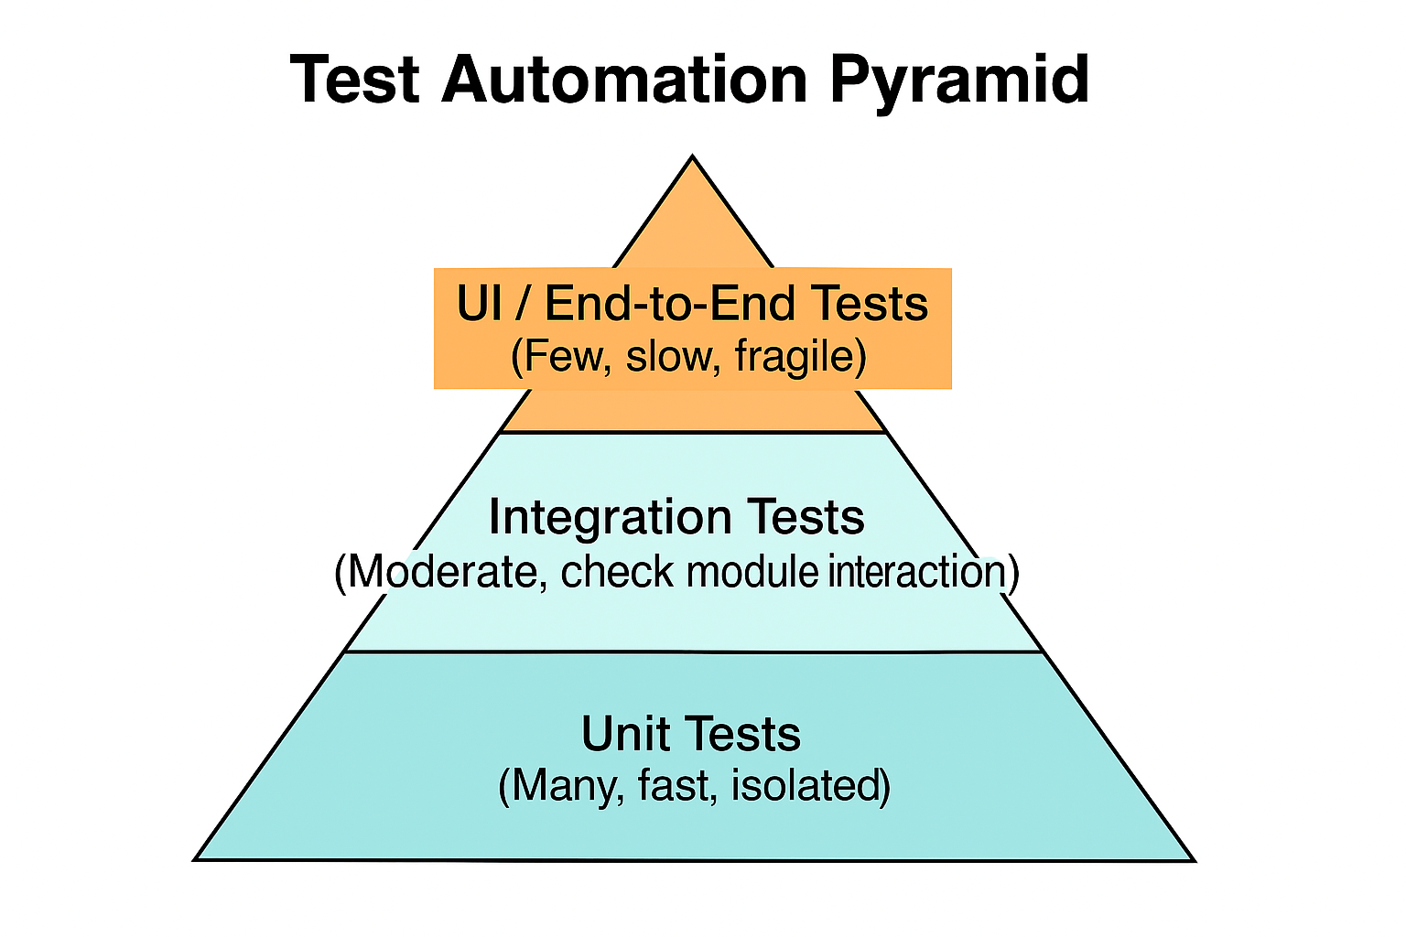

**3. Benefits of Software Testing in Traditional vs Agile Approaches**

Software testing has evolved significantly with the transition from traditional development models, such as the Waterfall model, to Agile methodologies. While the core goal—ensuring software quality—remains the same, the approach, mindset, and integration of testing into the development cycle differ in meaningful ways.

**3.1 Traditional Software Testing Approach**

In traditional software development models, testing is treated as a distinct phase that comes after coding is completed. This model emphasizes sequential stages—requirements, design, development, testing, and deployment—with limited flexibility for changes once development begins.

**Benefits of Traditional Approach:**

* **Well-Documented Testing Process:** Detailed documentation is created before testing begins, which ensures traceability and accountability.
* **Stable Testing Environment:** Testing is performed on a mostly stable product, which reduces volatility in test cases.
* **Predictable Schedules:** Since phases are predefined, the testing timelines are easier to estimate and manage.
* **Clear Role Separation:** Dedicated QA teams are responsible for testing, which maintains specialization and focus.

However, the drawback of this approach is the late detection of bugs, which leads to higher costs of fixing defects and reduced adaptability to changing requirements.

**3.2 Agile Software Testing Approach**

Agile testing is integrated throughout the development process. It follows the principles of continuous feedback, iterative improvement, and collaboration between developers, testers, and stakeholders.

**Benefits of Agile Testing:**

* **Early and Continuous Testing:** Bugs are caught early, reducing the cost and time to fix them.
* **Better Collaboration:** Developers and testers work together closely, ensuring high code quality.
* **Faster Time to Market:** Continuous testing allows frequent releases and rapid iteration.
* **Adaptability to Change:** Agile encourages flexibility, allowing test cases to evolve with changing requirements.
* **Test Automation:** Agile heavily relies on automated testing frameworks and CI/CD tools like Jenkins, Travis CI, and Selenium.
* **Improved Product Quality:** Continuous feedback loops result in better user-focused features and stable codebases.

Agile testing is particularly useful in AI/ML projects where model performance may shift over time, and rapid experimentation is essential. Automated regression tests, functional validations, and integration checks are frequently run with every iteration.

**4. Levels and Approaches of Software Testing**

Software testing is performed at multiple levels to ensure thorough verification and validation of the application at various stages of its development. Each level targets a specific part of the software system and serves a unique purpose in identifying issues before deployment.

**4.1 Levels of Software Testing**

**1. Unit Testing**

* Focuses on testing individual components, functions, or classes in isolation.
* Performed by developers during the coding phase.
* Fast and highly automated using tools like **JUnit**, **PyTest**, etc.
* Ensures that each unit performs as expected.

**2. Integration Testing**

* Tests the interactions between different modules or components.
* Detects issues in data flow, API contracts, and module dependencies.
* Can be top-down, bottom-up, or hybrid.
* Tools: **TestNG**, **Postman**, **REST Assured**.

**3. System Testing**

* Conducted on the complete, integrated system.
* Validates functional and non-functional requirements (performance, security, etc.).
* Performed by independent QA teams.
* Ensures the end-to-end behaviour of the application.

**4. Operational Acceptance Testing (OAT)**

* Simulates real-world production environments.
* Focuses on backup, recovery, failover, security, and user permissions.
* Ensures the software is ready for release and operational deployment.

**4.2 Approaches to Software Testing**

**1. Static Testing**

* Testing that doesn’t require code execution.
* Includes code reviews, walkthroughs, and static analysis tools.
* Helps in identifying syntax errors, code smells, and security flaws early.
* Tools: **SonarQube**, **Checkstyle**, **PMD**.

**2. Dynamic Testing**

* Requires code execution to validate behaviour and outputs.
* Can be both manual or automated.
* Focuses on runtime behaviour and performance.
* Used in unit, integration, system, and acceptance tests.

**3. Exploratory Testing**

* Simultaneous learning, test design, and execution.
* Carried out by experienced testers who explore the application without predefined test cases.
* Helps uncover unexpected issues and usability bugs.

**4. The Box Approaches:**

* **Black-Box Testing:** Tests based on input/output without knowledge of internal code. Used in system and acceptance testing.
* **White-Box Testing:** Internal logic and structure are tested. Typically used in unit testing.
* **Grey-Box Testing:** Combines both approaches—tester has partial knowledge of the system internals.

**5. Test-Driven Development (TDD) with JUnit**

**5.1 Overview of Test-Driven Development**

**Test-Driven Development (TDD)** is a software development methodology that emphasizes writing automated test cases before writing the actual code. It follows a short and repetitive cycle often summarized as **Red-Green-Refactor**:

1. **Write a test** for a new function or feature (Red — it fails initially).
2. **Write just enough code** to make the test pass (Green).
3. **Refactor** the code while keeping all tests passing.
4. **Repeat** the process for each new feature or functionality.

This method ensures that every unit of functionality is tested right from the beginning, resulting in cleaner, more maintainable, and bug-free code.

**5.2 Advantages of TDD**

* Early bug detection and fast feedback loop
* Encourages modular and loosely coupled code
* Improves code quality and maintainability
* Less debugging and rework
* Better understanding of requirements through test scenarios
* Facilitates continuous integration and automation
* Enhances developer confidence when refactoring code
* Leads to better-designed interfaces and APIs

**5.3 JUnit5: A Powerful TDD Framework**

**JUnit5** is the latest version of the widely-used Java testing framework. It offers a modern and flexible approach to writing unit tests with improved annotations and features compared to previous versions.

**Software Requirements:**

* Java SE 8 or higher
* Eclipse IDE or IntelliJ IDEA
* JUnit5 library

**Basic JUnit5 Annotations:**

* @Test — Marks a method as a test
* @BeforeEach — Runs before each test
* @AfterEach — Runs after each test
* @BeforeAll / @AfterAll — Run once before/after all tests
* @DisplayName — Describes test case in a readable format
* @Nested, @ParameterizedTest — For grouped and data-driven testing

**5.4 Sample TDD Cycle with JUnit5**

Let’s say we’re developing a simple method to check whether a number is prime.

**Step 1: Write the Failing Test (Red Phase)**

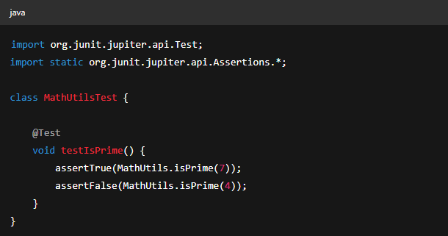

**Step 2: Write the Code to Make It Pass (Green Phase)**

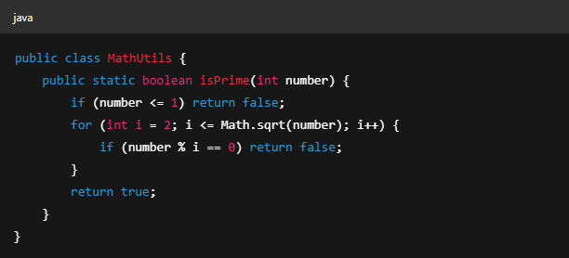

**6. Behaviour-Driven Development (BDD) with Cucumber**

**6.1 Overview of BDD**

**Behaviour-Driven Development (BDD)** is a software development approach that bridges the gap between technical and non-technical stakeholders. It extends the principles of TDD by using natural language constructs to describe the behaviour of a system.

BDD encourages collaboration among developers, testers, business analysts, and product owners by writing test scenarios in a shared language that everyone understands.

**Key Characteristics:**

* Focus on **“what” the system should do** rather than “how”.
* Uses **Gherkin syntax**: plain English formatted as Given–When–Then steps.
* Ensures that requirements are **testable**, **clear**, and **business-focused**.

**6.2 Gherkin Syntax Example**

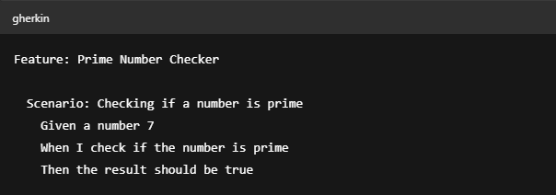

This makes it easy for both technical and non-technical team members to understand the expected behaviour.

**6.3 Cucumber Framework**

**Cucumber** is a popular BDD testing framework that supports multiple programming languages such as Java, JavaScript, Ruby, and Kotlin. It executes test scenarios written in Gherkin and maps them to step definitions written in code.

**6.4 Cucumber + Java Setup**

**Required Software:**

* Java SE (Java 8 recommended; not compatible with Java 9+)
* Maven (v3.3.1+)
* IntelliJ IDEA or Eclipse with Cucumber plugin

**Example Step Definition in Java:**

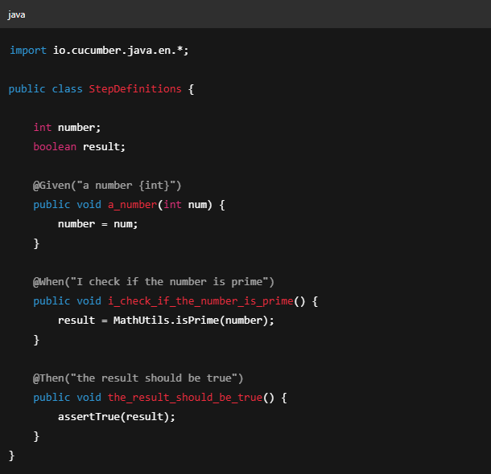

**6.5 BDD Across Languages**

Cucumber also supports other popular languages:

| **Language** | **Required Tools** |
| --- | --- |
| Java | IntelliJ, Maven, Cucumber Plugin |
| JavaScript | Node.js, Atom/VSCode/TextMate |
| Ruby | Ruby, Bundler, any text editor |
| Kotlin | IntelliJ with Kotlin and Cucumber plugins |

**6.6 Benefits of BDD**

* Improved collaboration between developers, testers, and stakeholders
* Clear, human-readable test cases
* Ensures software behaviour aligns with business expectations
* Promotes shared understanding and documentation
* Encourages writing tests before development

**6.7 Cucumber project structure diagram**

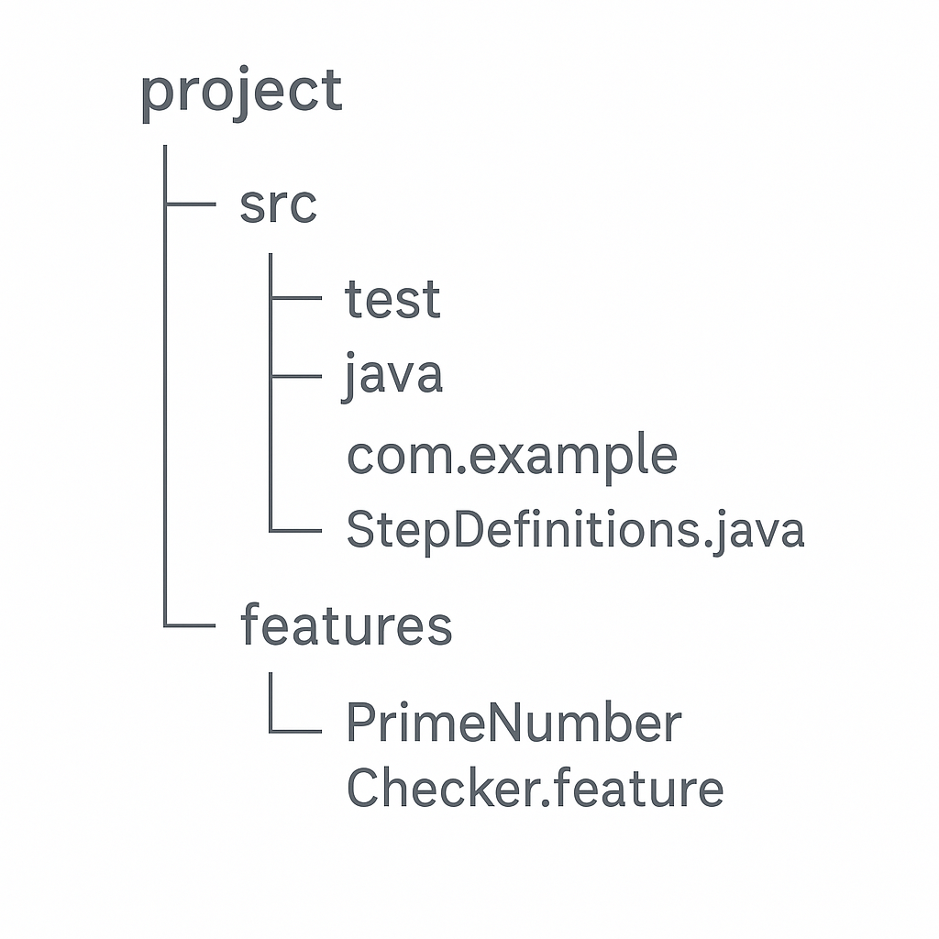

**7. Agile Testing Advantages**

Agile testing is not a standalone phase—it is a continuous and integrated process that begins at the start of the project and continues through each iteration or sprint. It aligns closely with Agile principles of flexibility, collaboration, and customer satisfaction, providing faster feedback and higher quality releases.

**7.1 Key Advantages of Agile Testing**

**Early and Continuous Feedback**

Testing is performed concurrently with development, enabling immediate identification and resolution of defects. This reduces the overall cost and complexity of bug fixes.

**Improved Product Quality**

Frequent testing ensures that software remains stable, functional, and aligned with evolving requirements. Agile teams often use test-first strategies such as TDD and BDD to maintain high code quality.

**Better Collaboration**

Agile promotes strong collaboration between developers, testers, business analysts, and stakeholders. Quality becomes a shared responsibility rather than a siloed task.

**Flexibility to Change**

As priorities and user stories evolve, Agile testing adapts to changes quickly. Test cases

and scripts are continuously updated to reflect new requirements.

**Automated Testing and CI/CD Integration**

Agile teams rely heavily on automation tools like Jenkins, Travis CI, Selenium, and JUnit5. Automated tests are run with every code integration to ensure rapid and reliable builds.

**Faster Time to Market**

By testing early and continuously, teams can deliver working software more frequently. Agile supports incremental delivery, reducing time between concept and release.

**Customer-Centric Focus**

Agile testing emphasizes delivering value. User stories, demos, and acceptance criteria are driven by customer needs and feedback, improving satisfaction and usability.

**8. Popular Software Testing Techniques**

Software testing techniques provide structured approaches for validating different aspects of an application—from functionality to usability, security, and performance. A good testing strategy often combines several of these methods to ensure comprehensive coverage.

**8.1 Functional vs Non-Functional Testing**

**Functional Testing**

Focuses on what the system does. It validates features against requirements using test cases derived from user stories or specifications.

Examples: Unit testing, integration testing, system testing, regression testing.

**Non-Functional Testing**

Evaluates how the system behaves under certain conditions. It measures usability, performance, security, and reliability.

Examples: Load testing, stress testing, usability testing, security testing.

**8.2 Key Techniques in Practice**

**A/B Testing**

Compares two versions of a feature (A and B) to determine which performs better based on user behaviour. Commonly used in UI/UX design, marketing features, and conversion optimization.

**Usability Testing**

Assesses how easy and intuitive the software is for end-users. Testers observe real users as they interact with the application to identify pain points or confusion.

**Security Testing**

Focuses on identifying vulnerabilities that could be exploited. It includes penetration testing, authentication checks, and data protection assessments.

**Continuous Testing**

In Agile and DevOps environments, automated tests are run frequently as part of the CI/CD pipeline. It helps detect issues early and maintain deployment readiness.

**Alpha Testing**

Performed internally by developers or QA teams at the end of development but before the product is released to users. Focuses on bug fixing and performance validation.

**Beta Testing**

Conducted by real users in a real environment. It provides feedback from actual usage and helps identify unexpected issues before full-scale release.

**Regression Testing**

Ensures that new code changes don’t unintentionally break existing functionality. Often automated and included in CI workflows.

**Smoke Testing**

A quick set of high-level tests to check if the basic functionalities are working. Often referred to as “build verification testing.”

Sanity Testing

Performed after receiving a new build to verify that specific bugs have been fixed and no new major issues have been introduced.

These techniques are often combined based on the project’s size, complexity, and development model to ensure robust and user-centered software delivery.

**9. Automation Testing Frameworks and Tools**

As modern software development cycles become shorter and more iterative, automation testing plays a crucial role in ensuring speed, reliability, and coverage. Automation frameworks provide structured environments to create, organize, and execute test cases efficiently.

**9.1 Popular Automation Testing Tools**

Here are some widely adopted tools used across industries:

| **Tool** | **Purpose** |
| --- | --- |
| **Selenium** | Web application testing in multiple browsers |
| **TestNG** | Advanced test configuration and parallel execution |
| **JUnit5** | Unit testing framework for Java |
| **Appium** | Mobile app automation for Android and iOS |
| **Coderunner** | Lightweight test execution environment |
| **Jenkins** | CI/CD tool for integrating and automating tests |
| **SoapUI** | API testing (REST and SOAP) |
| **Robot Framework** | Generic automation with tabular test cases |
| **RSpec** | BDD-style testing for Ruby |
| **Eggplant Functional** | Intelligent UI testing based on AI & image recognition |
| **Mocha** | JavaScript test framework (Node.js) |
| **Jasmine** | Behaviour-driven testing for JavaScript |

**9.2 Types of Automation Testing Frameworks**

Each framework offers a different approach depending on how tests are structured, written, and maintained.

**1. Linear Scripting Framework**

* Record and playback approach.
* Minimal programming knowledge required.
* Best suited for small projects.

**2. Modular Testing Framework**

* Test scripts are broken down into smaller, reusable modules.
* Improves maintainability and scalability.

**3. Data-Driven Testing Framework**

* Test logic is separated from test data.
* Allows multiple data sets to be tested using external sources (Excel, CSV, DB).

**4. Keyword-Driven Testing Framework**

* Uses predefined keywords representing actions (e.g., click, input, validate).
* Enables testers to create tests without writing code.

**5. Hybrid Testing Framework**

* Combines two or more frameworks (e.g., Data-Driven + Keyword).
* Offers greater flexibility and control.

**6. Behaviour-Driven Development Framework**

* Uses human-readable test scenarios (e.g., Gherkin syntax in Cucumber).
* Encourages collaboration between developers, testers, and business teams.

**9.3 Integration with CI/CD Pipelines**

Tools like **Jenkins**, **Travis CI**, and **GitHub Actions** enable the continuous execution of test cases as soon as code is committed. This ensures rapid feedback and promotes stable, deployable builds at all times.

**Example Flow:**

1. Developer pushes code to GitHub.
2. Jenkins triggers the build.
3. Automated tests run using Selenium + TestNG.
4. Results are reported and integrated into the pipeline.

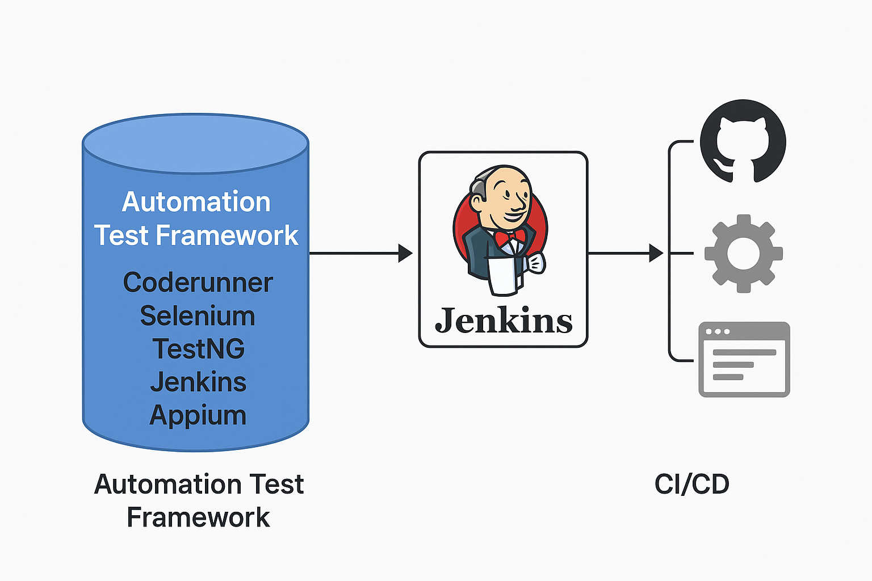

**10. Static vs Dynamic Testing**

Understanding the difference between static and dynamic testing helps in applying the right method at the right stage of the software development lifecycle.

**10.1 Static Testing**

**Definition:**  
Static testing involves examining the software artifacts—such as source code, requirement documents, and design diagrams—*without executing the code*.

**Purpose:**

To identify defects early in the development cycle before the code is run. It’s focused on **prevention** rather than detection.

**Common Activities:**

* Code Reviews
* Static Analysis (using tools)
* Walkthroughs
* Inspections

**Advantages:**

* Catches errors early and cheaply
* No need for compiled code
* Helps improve code structure and documentation
* Reduces downstream bugs

**Examples of Static Testing Tools:**

* SonarQube
* Checkstyle
* PMD

**10.2 Dynamic Testing**

**Definition:**  
Dynamic testing involves *executing the code* to check for functional correctness, performance, and other run-time behaviours.

**Purpose:**  
To validate that the software behaves as expected during execution and meets the business and technical requirements.

**Common Activities:**

* Unit Testing
* Integration Testing
* System Testing
* Acceptance Testing

**Advantages:**

* Ensures actual behaviour matches expected behaviour
* Detects defects that can't be found through static methods
* Essential for end-to-end validation

**Examples of Dynamic Testing Tools:**

* Selenium
* JUnit
* TestNG
* Appium
* **Comparison Table**

| **Feature** | **Static Testing** | **Dynamic Testing** |
| --- | --- | --- |
| **Code Execution** | Not required | Required |
| **Timing** | Early in development | After code implementation |
| **Focus** | Prevention | Detection and correction |
| **Tools** | SonarQube, PMD | Selenium, JUnit, Appium |
| **Cost of Fixing Bugs** | Lower | Higher |

This dual approach ensures better software quality by combining early error prevention (static) with run-time validation (dynamic).

**11. The Exploratory and Box Approaches to Testing**

Different testing methodologies provide different lenses through which to examine software. Two key categories in this context are **Exploratory Testing** and the **Box Testing Approaches** (White Box, Black Box, and Gray Box testing).

**11.1 Exploratory Testing**

**Definition:**  
Exploratory testing is an informal, hands-on approach where testers actively explore the software without pre-defined test cases. It relies on the tester's intuition, experience, and knowledge of the system.

**Key Characteristics:**

* Simultaneous learning, test design, and test execution.
* Adapts to the behaviour of the application as it's being tested.
* Focuses on discovery, investigation, and creativity.

**When to Use:**

* In early development stages.
* When documentation is limited or requirements are still evolving.
* For identifying unusual bugs or behaviours not captured by scripted tests.

**Advantages:**

* Encourages critical thinking.
* Uncovers hidden or non-obvious issues.
* Helps test from a real-user perspective.

**11.2 Box Testing Approaches**

These approaches define *what* the tester knows about the internal structure of the application.

**a. White Box Testing (Clear Box Testing)**

**Focus:** Internal logic and structure of the code.  
**Testers Know:** How the code is written and can access it.  
**Examples:** Unit testing, code path coverage, branch testing.

**Use Cases:**

* Verifying logic flow and loop conditions.
* Ensuring all paths and conditions are tested.
* Ideal for developers and test automation engineers.

**b. Black Box Testing**

**Focus:** Inputs and outputs of the system—*without any knowledge of the internal workings*.  
**Testers Know:** Only functional requirements and expected outcomes.  
**Examples:** System testing, acceptance testing, UI testing.

**Use Cases:**

* Validating end-user scenarios.
* Ensuring compliance with business requirements.
* Suitable for QA engineers, manual testers, and end-users.

**c. Gray Box Testing**

**Focus:** Partial knowledge of the internal structure combined with external behaviour.  
**Testers Know:** Some information about the system architecture or design.  
**Examples:** Integration testing, security testing.

**Use Cases:**

* When balancing between code-level insight and user-level behaviour.
* Security and data flow validations.
* **Summary Table**

| **Approach** | **Internal Knowledge** | **Typical Tests** | **Performed By** |
| --- | --- | --- | --- |
| White Box | Full | Unit, Integration | Developers |
| Black Box | None | System, Acceptance | QA Testers |
| Gray Box | Partial | Security, Integration | Testers/Developers |
| Exploratory | Ad-hoc/Intuitive | UI/Usability/Edge Cases | Skilled Testers |

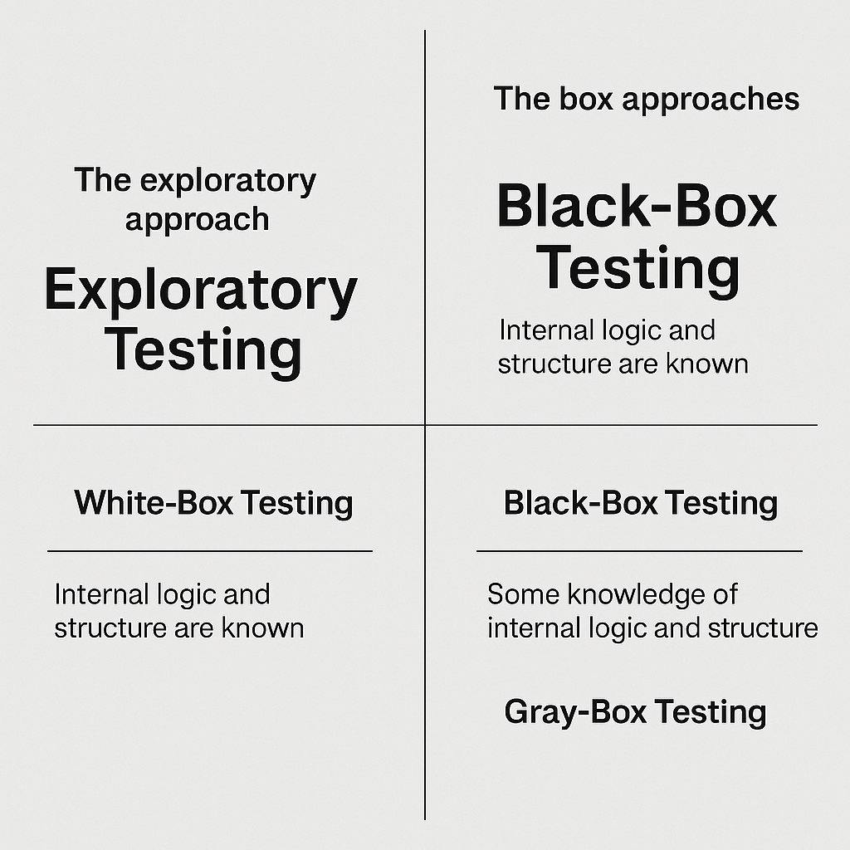

**12. Software Testing Levels**

Software testing is conducted at various levels throughout the development lifecycle to ensure every component and the system as a whole function correctly. These levels follow a bottom-up or top-down approach depending on the development methodology used.

**12.1 Unit Testing**

**Purpose:**  
To test individual components or functions in isolation.

**Performed By:**

Developers  
**Tools:** JUnit, NUnit, TestNG

**Characteristics:**

* Focuses on logic and internal behaviour of functions/methods.
* Fast execution and highly automated.
* Essential for catching errors early.

**12.2 Integration Testing**

**Purpose:**  
To verify the interactions between modules and how data flows between them.

**Performed By:**

Developers or QA Engineers

**Tools:** JUnit, Postman (for APIs), Selenium, Mockito

**Approaches:**

* **Top-Down Integration:** Tests start from the top-level modules and integrate downward.
* **Bottom-Up Integration:** Begins with testing lower modules first.
* **Big Bang:** All components are integrated and tested together (not recommended for complex systems).

**12.3 System Testing**

**Purpose:**  
To validate the complete and fully integrated system against the specified requirements.

**Performed By:** QA/Test Engineers  
**Tools:** Selenium, QTP, Robot Framework

**Characteristics:**

* Black box testing.
* Covers functional and non-functional aspects like usability, performance, and compatibility.
* Simulates real-world usage scenarios.

**12.4 Operational Acceptance Testing (OAT)**

**Purpose:**  
To assess readiness for deployment and check if the system meets operational requirements.

**Performed By:** Operations and Release Teams  
**Focus Areas:**

* Backup and recovery
* Load handling
* Security and access control
* Compliance with regulations
* Disaster recovery procedures

**Summary Table**

| **Level** | **Objective** | **Key Focus Area** | **Performed By** |
| --- | --- | --- | --- |
| Unit Testing | Validate individual functions/modules | Logic, internal behaviour | Developers |
| Integration Testing | Validate interaction between components | Data flow, APIs | Devs / Testers |
| System Testing | Validate end-to-end system behavior | Features, UI, performance | QA Team |
| Operational Acceptance | Validate production readiness | Stability, deployment | Ops / Release Team |

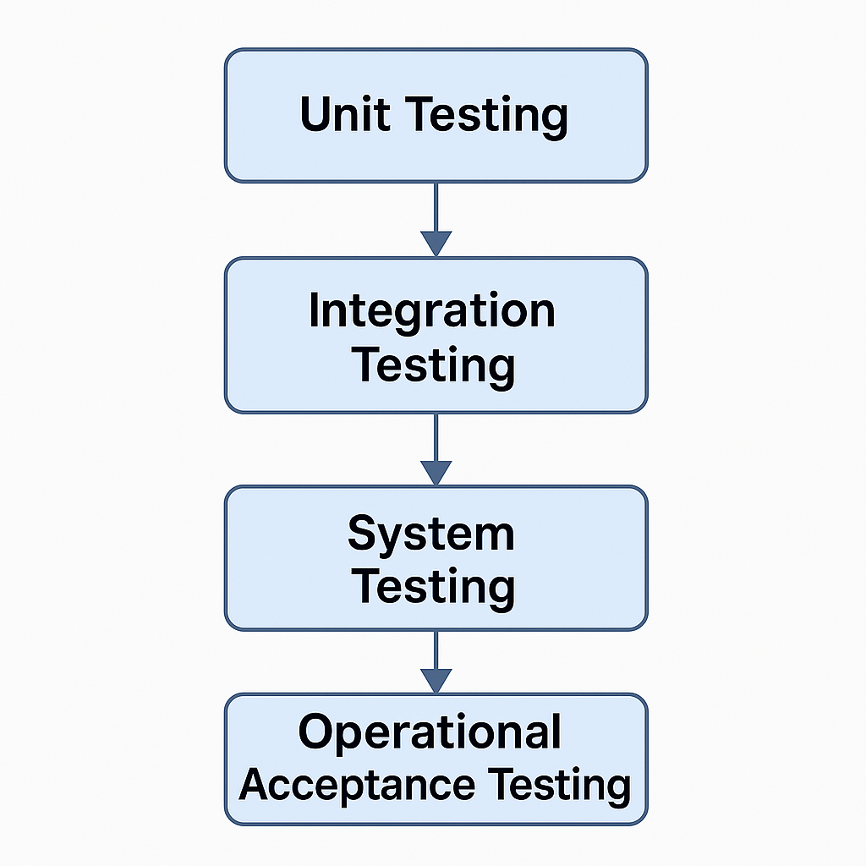

**13. Test-Driven Development (TDD) and Behavior-Driven Development (BDD)**

Both **TDD** and **BDD** emphasize writing tests early and using them to guide software development, but they differ in **focus, audience**, and **format**.

**13.1 Test-Driven Development (TDD)**

**Definition:**  
TDD is a development process where test cases are written before the actual code. The development follows a short cycle: write a failing test, write code to pass the test, then refactor.

**TDD Cycle**

1. **Add a test**
2. **Run the test** – it should fail
3. **Write the minimal code** to make the test pass
4. **Run all tests**
5. **Refactor the code**
6. **Repeat**

**Advantages of TDD**

* Early bug detection
* Better code structure and modularity
* Fast feedback loop
* Promotes good design and documentation
* Easier refactoring with confidence
* Increases productivity and code quality

**JUnit 5 for TDD**

**JUnit 5** is a popular testing framework used for implementing TDD in Java projects.

**Benefits of JUnit 5:**

* Supports test lifecycle methods (@BeforeEach, @AfterEach)
* Better IDE integration
* More expressive and flexible
* Compatible with modern Java features (Java 8+)

**TDD Project Requirements (Java + JUnit):**

* Java SE (8 or higher)
* Eclipse IDE / IntelliJ IDEA
* JUnit 5 library

**13.2 Behaviour-Driven Development (BDD)**

**Definition:**  
BDD extends TDD by using natural language to describe the behaviour of an application. It improves communication between developers, testers, and stakeholders using a **common language**.

**Key Components:**

* **Gherkin Syntax:** Uses plain English with keywords like Given, When, Then
* **Cucumber Framework:** Parses Gherkin files and connects them to code

**BDD Principles:**

* Focus on **business-readable scenarios**
* Encourages collaboration between technical and non-technical team members
* Tests describe **behaviour**, not implementation

**Tools & Language Support:**

| **Language** | **Framework** | **Required Software** |
| --- | --- | --- |
| Java | Cucumber | Java SE, Maven, IntelliJ / Eclipse + Plugin |
| JavaScript | Cucumber.js | Node.js, VSCode / Atom |
| Ruby | Cucumber | Ruby, Bundler, TextMate / other editors |
| Kotlin | Cucumber | Java SE, Maven, IntelliJ w/ Kotlin plugin |

**TDD vs BDD Summary**

| **Aspect** | **TDD** | **BDD** |
| --- | --- | --- |
| Focus | Code correctness | System behaviour |
| Language | Programming language | Natural language (Gherkin) |
| Stakeholder Friendly | Low | High |
| Tool Example | JUnit, TestNG | Cucumber, SpecFlow |
| Output | Unit tests | Executable specifications |

**14. Agile Testing and Its Advantages**

Agile testing is a software testing practice that follows the principles of agile software development. Unlike the traditional model, testing in agile happens **concurrently** with development and is deeply collaborative, iterative, and user-focused.

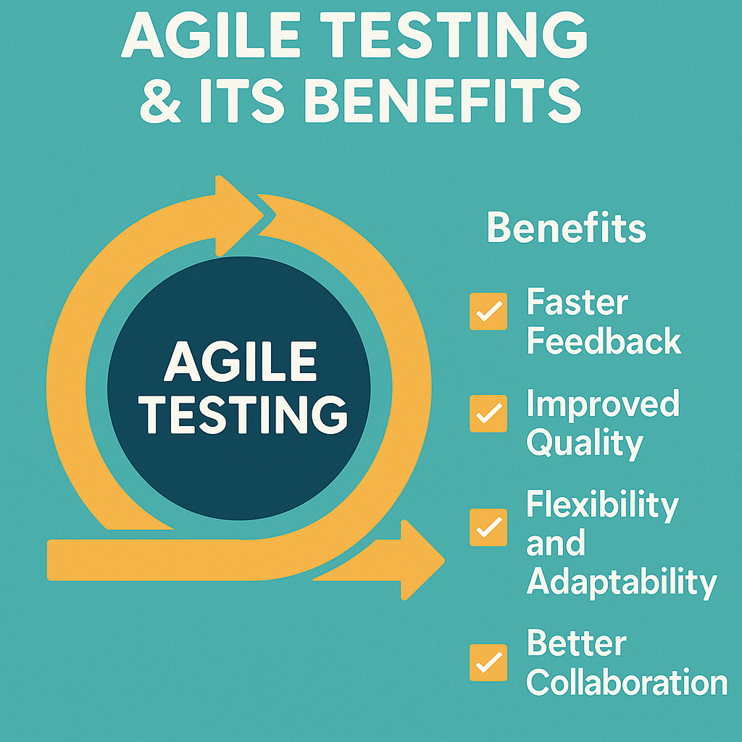

**14.1 What is Agile Testing?**

Agile testing doesn’t wait for the entire codebase to be completed. Instead, it is:

* **Continuous**: Testing occurs regularly and throughout the development lifecycle.
* **Collaborative**: Involves developers, testers, and stakeholders working closely.
* **Adaptive**: Responds to changes quickly with fast feedback loops.
* **Customer-Centric**: Driven by user stories and acceptance criteria.

Agile testing is not a phase—it is an **ongoing activity**.

**14.2 Key Characteristics of Agile Testing**

* **Test early and often**: Testing starts from day one and is done continuously.
* **Automated testing is prioritized**: To support rapid delivery and regression checks.
* **User stories and acceptance tests** drive testing objectives.
* **Frequent builds and CI/CD pipelines** are leveraged to catch issues early.
* **Quick feedback cycles**: Promotes faster decision-making and iteration.

**14.3 Agile Testing Quadrants**

**Agile testing can be categorized using Brian Marick’s Agile Testing Quadrants:**

| **Quadrant** | **Type of Test** | **Purpose** | **Tools Examples** |
| --- | --- | --- | --- |
| **Q1** | **Unit & Component Tests** | **Support developers** | **JUnit, TestNG, xUnit** |
| **Q2** | **Functional, Story, Prototypes** | **Support the team** | **Selenium, Cucumber, Jest** |
| **Q3** | **Exploratory, Usability, Scenarios** | **Guide the product** | **Manual, BugMagnet, Lookback** |
| **Q4** | **Performance, Load, Security** | **Critique the product** | **JMeter, LoadRunner, OWASP ZAP** |

**14.4 Advantages of Agile Testing**

* **Faster Feedback**: Bugs are identified and resolved early.
* **Better Collaboration**: QA, devs, and business teams work together.
* **Flexibility**: Responds well to change with continuous integration.
* **Improved Product Quality**: Frequent testing ensures fewer production bugs.
* **Customer Satisfaction**: Early validation with stakeholders keeps requirements aligned.
* **Reduced Costs**: Early defect detection and less rework lower overall expenses.
* **Early Automation**: Promotes CI/CD and reduces manual effort in the long run.
* **Shift Left**: Testing is integrated into development from the start.

**15. Popular Software Testing Techniques**

Modern software development embraces a wide range of testing techniques to ensure functionality, usability, performance, and security across different environments. Here’s a breakdown of the most widely used and effective techniques:

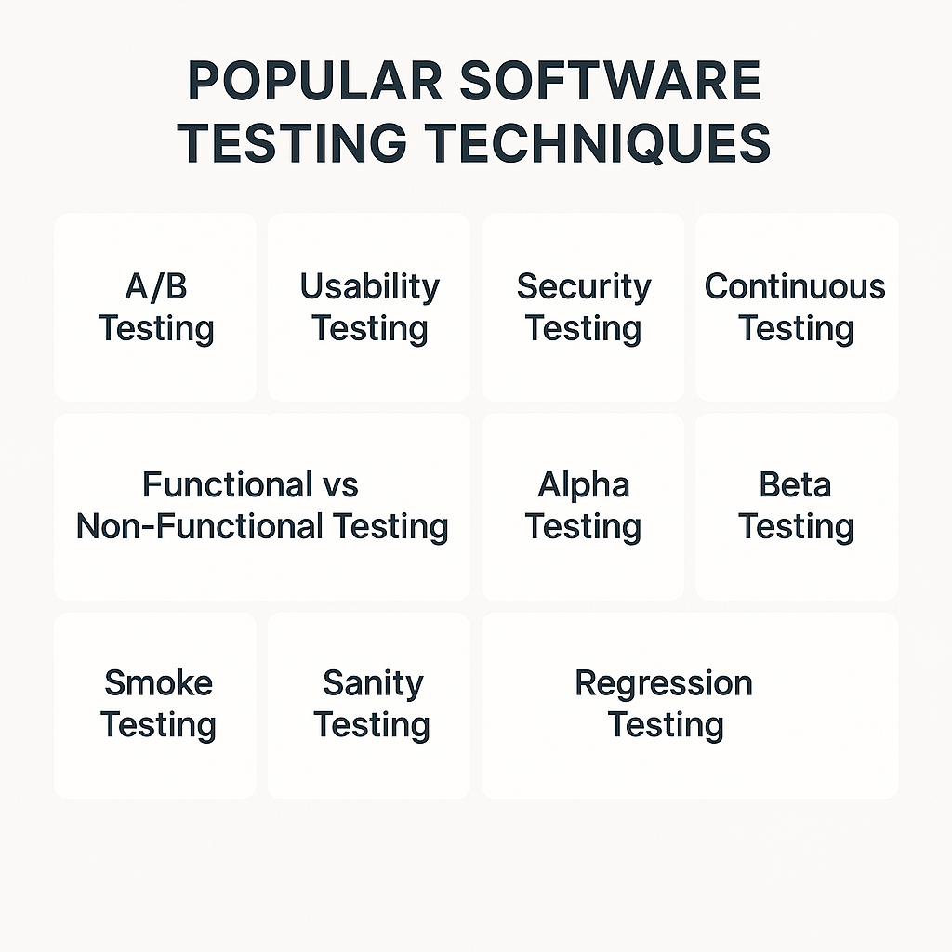

**15.1 A/B Testing**

**Purpose:**  
To compare two versions of a feature or interface (Version A and B) to determine which one performs better based on user interaction or conversion metrics.

**Use Case:**

* UI/UX testing
* Marketing campaigns
* Feature rollouts

**Benefits:**

* Data-driven decision-making
* Better user engagement

**15.2 Usability Testing**

**Purpose:**  
To evaluate the software's user interface and experience by testing with real users.

**Focus Areas:**

* Navigation clarity
* Accessibility
* Visual hierarchy

**Benefits:**

* Improves user satisfaction
* Highlights areas of friction

**15.3 Security Testing**

**Purpose:**  
To identify vulnerabilities, risks, and threats in the application and ensure data protection.

**Common Methods:**

* Penetration testing
* Authentication checks
* Input validation

**Tools:** OWASP ZAP, Burp Suite

**15.4 Continuous Testing**

**Purpose:**  
To test software continuously at every stage of development within the CI/CD pipeline.

**Benefits:**

* Faster delivery
* Early bug detection
* Reduced release risk

**Tools:** Jenkins, Travis CI, CircleCI

**15.5 Functional vs Non-Functional Testing**

| **Type** | **Description** | **Examples** |
| --- | --- | --- |
| Functional | Validates features against requirements | Login, search, checkout |
| Non-Functional | Checks performance, scalability, and usability | Load, stress, security, UX |

**15.6 Alpha Testing**

**Purpose:**  
Performed by internal employees/testers at the end of development to identify major bugs before external release.

**Focus:**  
Functionality, usability, and stability.

**15.7 Beta Testing**

**Purpose:**  
Real users test the product in a real environment before the final release.

**Goal:**  
Gather user feedback, identify issues missed in alpha testing.

**15.8 Regression Testing**

**Purpose:**  
To ensure that new changes haven’t broken existing functionality.

**When:**  
After code updates, bug fixes, or enhancements.

**Tools:** Selenium, TestNG, JUnit

**15.9 Smoke Testing**

**Purpose:**  
To perform basic checks to ensure the system is stable enough for further testing.

**Example:**  
App starts, login page loads, database connection works.

**15.10 Sanity Testing**

**Purpose:**  
Quick testing of specific functionalities after changes or fixes to confirm they work as expected.

**Difference from Smoke Testing:**

Smoke is broad & shallow; sanity is narrow & deep.

**16. Automation Testing Frameworks**

Automation testing frameworks provide structured ways to write, manage, and execute automated test cases efficiently. A well-designed framework improves test accuracy, reusability, and reduces maintenance overhead.

**16.1 What is an Automation Testing Framework?**

An **automation testing framework** is a set of rules, guidelines, and tools used to create and manage test scripts systematically. It ensures **consistency, modularity**, and **efficiency** in test automation projects.

**16.2 Types of Automation Testing Frameworks**

**1. Linear Scripting Framework**

* Also known as Record & Playback.
* Best for small-scale projects.
* Little to no reusability.
* Tools: Selenium IDE, UFT

**2. Modular Testing Framework**

* Test cases are divided into small, independent modules.
* Enhances reusability.
* Requires scripting knowledge.

**3. Data-Driven Framework**

* Test data is separated from test scripts (e.g., stored in Excel, CSV, JSON).
* Allows the same script to run with multiple data sets.
* Useful for large data volume testing.

**4. Keyword-Driven Framework**

* Uses keywords for each action (e.g., Click, EnterText, Verify).
* Easier for non-technical users.
* High reusability and maintainability.

**5. Hybrid Testing Framework**

* Combines features of multiple frameworks (data-driven + keyword-driven + modular).
* Most widely used in real-world projects.

**6. Behaviour-Driven Development (BDD) Framework**

* Focuses on collaboration between devs, testers, and business.
* Uses plain English (Gherkin syntax) for writing test cases.
* Tools: **Cucumber**, **SpecFlow**, **Behave**
* **16.3 Popular Tools for Automation Frameworks**

| **Tool** | **Usage Area** |
| --- | --- |
| **Selenium** | Web application automation |
| **Appium** | Mobile application automation |
| **JUnit5/TestNG** | Unit testing in Java |
| **Cucumber** | BDD testing |
| **CodeRunner** | Lightweight editor & runner |
| **Jenkins** | CI/CD integration |

**Framework Selection Criteria**

* **Project size & complexity**
* **Skill level of the team**
* **Reusability and scalability requirements**
* **Integration with CI/CD tools**
* **Support for multiple platforms/browsers/devices**

**17. Popular Testing Tools**

The software testing ecosystem is rich with tools tailored for different types of testing—ranging from unit testing and automation to performance and API testing. Below are some of the most widely adopted tools across industries:

**17.1 SoapUI**

**Type:** API Testing Tool

**Use Case:**

* Functional and load testing of REST and SOAP APIs
* Supports automation and security testing of web services

**Highlights:**

* Easy drag-and-drop interface
* Extensive support for assertions
* Integration with CI/CD tools like Jenkins

**17.2 Robot Framework**

**Type:** Open-source Automation Framework  
**Use Case:**

* Acceptance testing and robotic process automation (RPA)
* Keyword-driven and data-driven testing

**Highlights:**

* Simple plain text syntax
* Extensible with Python and Java libraries
* Supports Selenium, Appium, and REST APIs

**17.3 RSpec**

**Type:** Testing tool for Ruby

**Use Case:**

* Unit testing and BDD-style specifications in Ruby applications

**Highlights:**

* Human-readable DSL (domain-specific language)
* Strong integration with Ruby on Rails

**17.4 Eggplant Functional**

**Type:** GUI Automation and Functional Testing

**Use Case:**

* Testing real user experiences across devices
* Ideal for mobile and cross-platform testing

**Highlights:**

* AI-powered testing
* Image-based and visual validation
* Non-invasive approach (no code injection required)

**17.5 Mocha**

**Type:** JavaScript Test Framework

**Use Case:**

* Unit and integration testing for Node.js and browser apps

**Highlights:**

* Works well with assertion libraries like Chai
* Asynchronous test support
* Clean and descriptive test reports

**17.6 Jasmine**

**Type:** JavaScript Testing Framework

**Use Case:**

* Behaviour-driven development for frontend JavaScript apps

**Highlights:**

* No dependencies needed (runs standalone)
* Used heavily with Angular
* Spy and mocking support

**Tool Selection Summary Table**

| **Tool** | **Language/Platform** | **Primary Use** |
| --- | --- | --- |
| **SoapUI** | Java | API Functional & Load Testing |
| **Robot Framework** | Python, Java | Keyword & Acceptance Testing |
| **RSpec** | Ruby | Unit & BDD Testing |
| **Eggplant** | Cross-platform | GUI, Image-based Testing |
| **Mocha** | JavaScript (Node.js) | Unit & Integration Testing |
| **Jasmine** | JavaScript (Browser) | BDD for Frontend Apps |

These tools are chosen based on **language support, test type, scalability, CI/CD compatibility**, and **community support**.

**18. Conclusion and Key Takeaways**

The journey through *Software Testing* reveals how essential and multidimensional this field is within software engineering—especially in the context of AI-driven and agile-centric development.

**18.1 Summary**

* **Software testing** is not just about identifying bugs—it's about ensuring quality, reliability, and user satisfaction.
* It spans across **manual and automated techniques**, encompassing **unit testing to operational acceptance testing**.
* With the shift toward **agile methodologies**, testing has become **continuous, collaborative**, and **feedback-driven**.
* The adoption of **TDD (Test-Driven Development)** and **BDD (Behavior-Driven Development)** has promoted writing more meaningful and maintainable code.
* **Automation frameworks** and tools like **Selenium, JUnit5, Appium, Jenkins**, and **Cucumber** help teams scale testing to meet fast-paced development.
* Modern tools like **SoapUI, Robot, Mocha, Jasmine, and Eggplant** offer specialized capabilities across API, GUI, and behavioral testing domains.
* Testing in AI systems also involves **newer challenges** like data validation, fairness, bias detection, and model explainability.

**18.2 Key Takeaways**

* Start testing **early** and **test often** – this reduces cost and effort.
* Choose the **right approach** and **framework** based on your project’s nature.
* **Automate wisely** – not everything needs automation; focus on repeatable and time-consuming tasks.
* Embrace **CI/CD** for seamless integration of testing in development workflows.
* Stay updated with the **latest tools** and **best practices** to match the evolving tech landscape.
* In AI-focused development, include **validation of data and model behavior** as part of your testing strategy.

**Planning and Preparation**

**Software Testing Simulation Project**

For this academic simulation project, planning is essential to demonstrate not just testing theory but its practical application using real tools and frameworks. This phase defines the scope, tools, timeline, and expected outcomes.

**Project Overview**

**Title:** *Mini Software Testing Simulation using JUnit & Selenium*

Objective: To simulate software testing in a real-world environment using automation tools, covering test planning, execution, and reporting.

**Key Goals**

* **Apply concepts of Test-Driven Development (TDD) and Automation Testing**
* **Use JUnit5 for unit testing**
* **Use Selenium for browser-based UI testing**
* **Integrate with Maven and optionally Jenkins**
* **Create basic reports from test runs**

**Tools & Tech Stack**

| **Tool/Technology** | **Purpose** |
| --- | --- |
| **Java (JDK 17)** | **Main programming language** |
| **JUnit5** | **Unit testing framework** |
| **Selenium WebDriver** | **UI testing automation** |
| **Maven** | **Build and dependency manager** |
| **Eclipse / IntelliJ IDEA** | **IDE for writing and running tests** |
| **Jenkins (optional)** | **CI/CD and automation** |

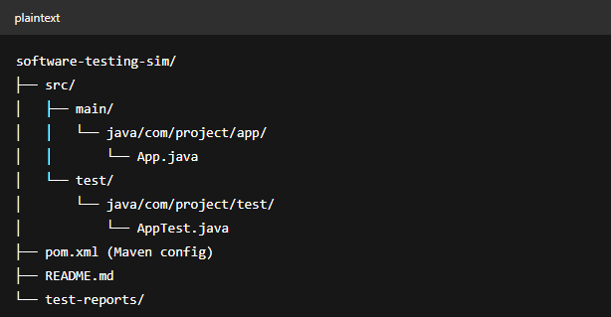

**Phases of Simulation**

| **Phase** | **Description** |
| --- | --- |
| **Requirement Analysis** | Define what the app should do |
| **Test Case Design** | Write unit test cases using JUnit5 |
| **Development** | Implement the app in Java |
| **Test Execution** | Run and validate all test cases |
| **Automation Integration** | Add Selenium and optionally Jenkins |
| **Documentation** | Include test results and summary report |

**Test Planning Milestones**

| **Date** | **Task** |
| --- | --- |
| Day 1–2 | Setup environment & structure |
| Day 3 | Write unit test cases |
| Day 4–5 | Code implementation + execution |
| Day 6 | Integrate Selenium tests |
| Day 7 | Final report + project zip |

**Expected Outcome**

* A **mini software module** with passing test cases
* Automated test reports using **JUnit**
* (Optional) Selenium script demonstrating UI test
* Project zip file and **documentation ready for submission**

**Key Components of the Identified Skill Sets**

In the domain of **Software Testing**, especially within the **AI and Agile ecosystem**, mastering certain core skills is critical for both manual and automated testing roles. These skill sets are not just technical—they also include analytical, organizational, and collaborative abilities.

**20.1 Technical Skills**

| **Skill** | **Description** |
| --- | --- |
| **Test Case Design** | Ability to design robust test cases covering functional and non-functional aspects. |
| **Programming Proficiency** | Writing and understanding code in languages like **Java**, **Python**, **JavaScript**, etc., is essential for writing unit and automation tests. |
| **Test Automation Tools** | Hands-on experience with tools like **JUnit, Selenium, Appium, TestNG**, and **Cucumber**. |
| **Version Control Systems** | Knowledge of **Git** for managing code and test versions. |
| **CI/CD Integration** | Familiarity with tools like **Jenkins**, **Travis CI**, and **GitHub Actions** for automated test execution. |
| **Bug Tracking Tools** | Experience with tools such as **Jira, Bugzilla, Mantis** to report and manage defects. |
| **IDE and Build Tools** | Working with **Eclipse, IntelliJ, Maven, Gradle** for test execution and project management. |

**20.2 Analytical and Problem-Solving Skills**

* **Root Cause Analysis (RCA):** Ability to diagnose why a test failed or a bug occurred.
* **Critical Thinking:** Evaluating requirements and designs to find potential edge cases and loopholes.
* **Scenario Modelling:** Creating real-world and extreme-use case scenarios for thorough testing.

**20.3 Process and Methodology Understanding**

* Understanding **SDLC** and **STLC** phases.
* Knowledge of **Agile**, **Scrum**, and **DevOps** workflows.
* Experience with **Test-Driven Development (TDD)** and **Behavior-Driven Development (BDD)** practices.

**20.4 Communication and Collaboration Skills**

* **Clear Bug Reporting:** Ability to articulate defect behavior and reproduction steps effectively.
* **Team Communication:** Interacting with developers, product owners, and other testers during sprint meetings.
* **Documentation:** Preparing test plans, test cases, and test summary reports clearly and concisely.

**20.5 Adaptability & Continuous Learning**

* Willingness to **learn new tools**, languages, and testing frameworks.
* Keeping up with **trends in AI testing**, cloud-based test platforms, and new automation practices.

**Proofs of outcome and feedback**